**Roll Off**

**Low Level Design (LLD)**

**DOCUMENT APPROVAL**

**Approvers of this document**

|  |  |  |  |  |
| --- | --- | --- | --- | --- |
| **Name** | **Department** | **Role** | **Signature** | **Date** |
|  |  |  |  |  |
|  |  |  |  |  |
|  |  |  |  |  |

**DOCUMENT CHANGE HISTORY**

|  |  |  |  |
| --- | --- | --- | --- |
| **Document**  **Version #** | **Author** | **Date** | **Description** |
|  |  |  |  |
|  |  |  |  |

**Contents**

1. **Document Purpose……………………………………………………………..03**
2. **Intended Audience……………………………………………………………..03**
3. **Project Background, Objective(s)…………………………………………….03**
   1. **Project Background…………………………………………………….03**
   2. **Project Objective………………………………………………………..03**
4. **Design Pattern………………………………………………………………….03**
5. **Solution Diagram………………………………………………………………04**
6. **Architecture Diagram…………………………………………………………04**
7. **Flow Diagram………………………………………………………………….05**
8. **Use Case Diagram……………………………………………………………..05**
9. **Class Diagram…………………………………………………………………06**
10. **E-R Diagram……………………………………………………………….06**
11. **User Requirements………………………………………………………...08**
    1. **Hardware…………………………………………………………..08**
    2. **Software…………………………………………………………….08**
12. **Developer Requirements ………………………………………………….08**
    1. **Hardware …………………………………………………………..08**
    2. **Software…………………………………………………………….08**
    3. **Technology…………………………………………………………08**
13. **Solution Steps…………………………………………………………………09**
14. **Document Purpose**

This document describes the solution architecture for Roll Off.

**2.0 Intended Audience**

**3.0 Project Background and Objective(s)**

**3.1 Project Background**

This application is mainly developed to make the process more efficient and smoother, minimizing the delays that were used to happen initially.

**3.2 Project Objective**

The main objective if this project is to act as an intermediate between the Account and the PSP department to ease the roll off process.

**4.0 Design Pattern**

|  |  |  |
| --- | --- | --- |
| # | Name | Description |
| 1 | ANGULAR | Angular is used for the frontend and designing of the application |
| 2 | API | API is used to process all the http  Requests. |
| 3 | SQL SERVER | SQL server is used to store data to the database |

**5.0 Solution Diagram**

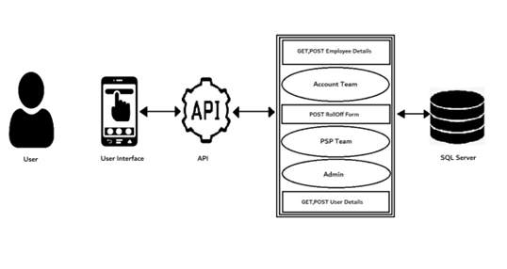

**6.0 Architecture Diagram**

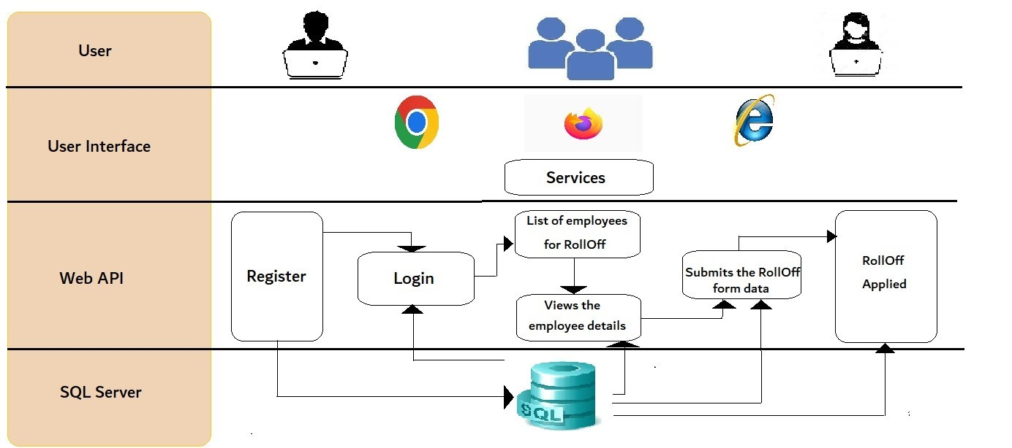

**7.0 Flow Diagram**

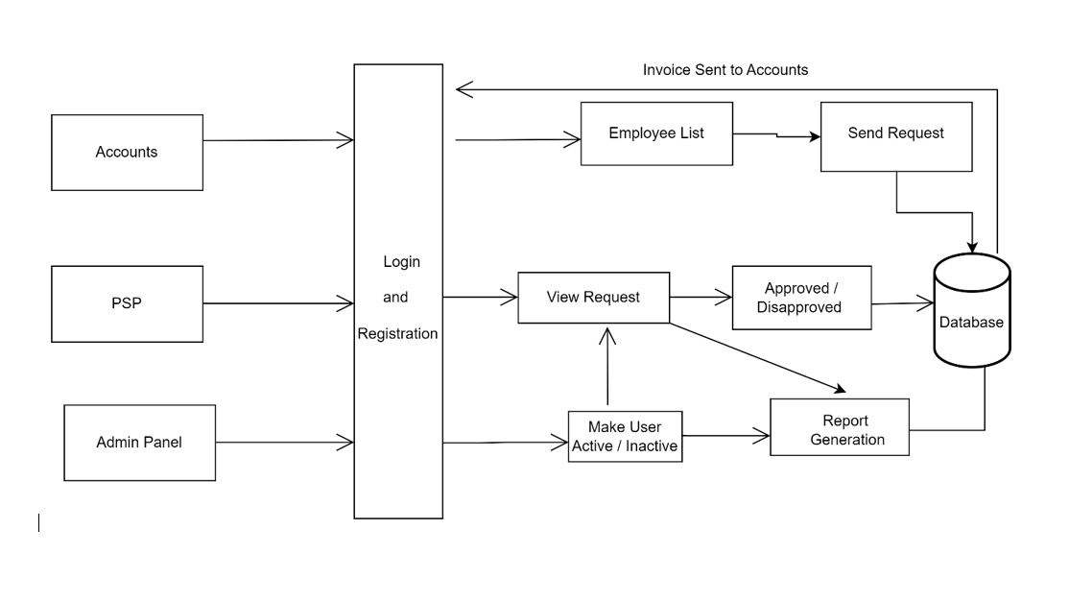

**8.0 Use Case Diagram**

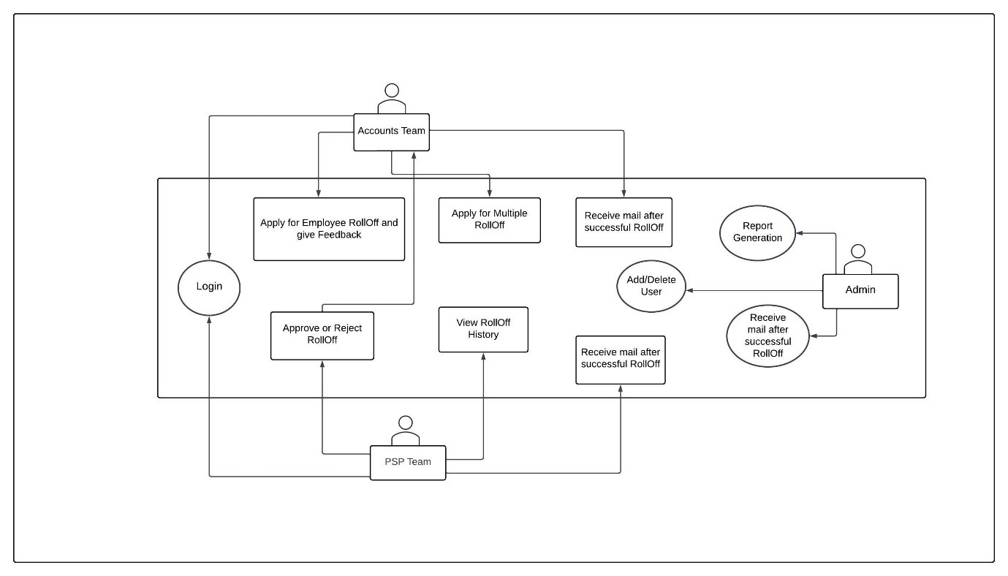

**9.0 Class Diagram**

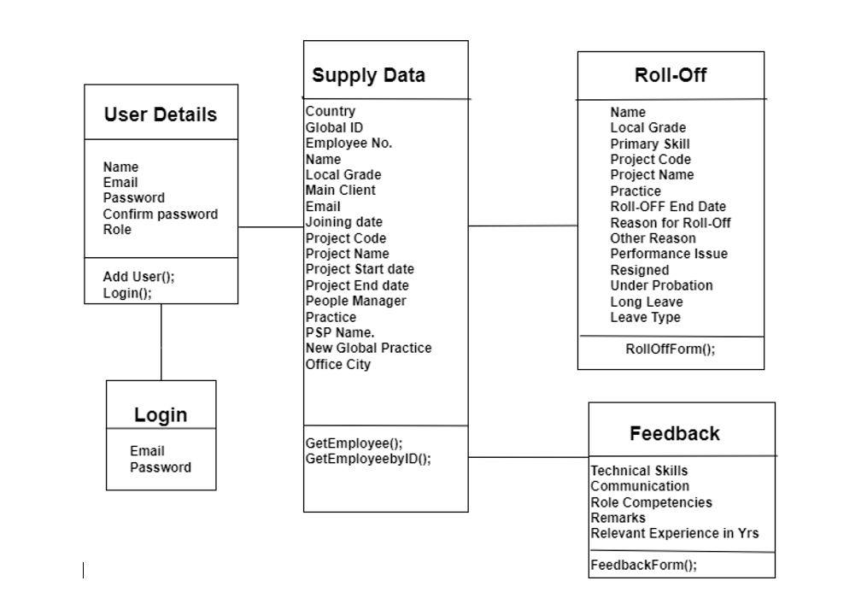

**10.0 E-R Diagram**

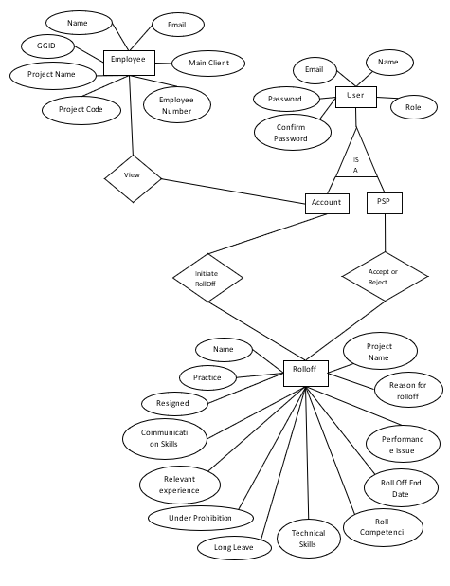

# 11.0 User Requirements

# 11.1 Hardware

# • Processor: Minimum 1.8 GHz. Recommended 2GHz or more.

# • Ethernet connection (LAN) OR a wireless adapter (Wi-Fi)

# • Hard Drive: Minimum 100 GB; Recommended 500GB or more.

# • Memory (RAM): Minimum 4 GB; Recommended 8 GB or above.

# • OS: Windows.

# 11.2 Software

# • Any Latest Browsers.

# 12.0 Developer Requirements

# 12.1 Hardware

# • Processor: Minimum 1.8 GHz. Recommended 2GHz or more.

# • Ethernet connection (LAN) OR a wireless adapter (Wi-Fi)

# • Hard Drive: Minimum 100 GB; Recommended 500GB or more.

# • Memory (RAM): Minimum 4 GB; Recommended 8 GB or above.

# • OS: Windows.

# 12.2 Software

# •Visual studio 2019.

# •SQL Server management studio.

# Node, Angular

# 12.3 Technology

# • ASP.NET for backend

# •SQL for the database operations

# • Angular for frontend.

**13.0 Solution Steps:**

1. **User Registration:**

The user needs to get registered with valid inputs that include Name, Email, password, confirm password and role.

The inputs will get validated, like none of the above field should be null.

1. **Rolling Off an employee:**

Firstly, user should get logged in to the system using valid credentials that are username, password, and role. Depending on the role the intended dashboard will get displayed.

Here, the account team will be able to view all the employee details and initiate the process of roll off. The feedback will also be sent by the account team.

1. **Approving the Roll off:**

Once the roll off is requested, it will get notified to the PSP team, where they will decide whether to accept the request or not.

Before accepting the request, they will look after the condition that if the notice period is less than 30 days it should be sent back to the account team asking for the clarification for the same.

1. **Feedback:**

Feedback is also sent form the accounts teams about an employee who is the process of getting rolled off from the project.